Project2：(Chong Li, 27813724)
Pay attention:
This is a fixed version of my project2, and i upload it after my demo.

The approach and design:

Based on project1(using spimi, realizing single word query and “and” operation), i changed two things:
1)the data structure, from {term:docid} to {term:{docic: termfrequency}} plus {docid: doclength}
2)the type of store file, from .txt file to .json file.(Because i find that .json file is more convenient for new type of data structure i used to store and extract the useful data)

- Read file + spimi:
read .sgm files from reuters21578 folder, do the spimi process: read the file line by line. Remove those punctuation, and tokenize the <body></body> part, generate a special dictionary:{term:{docic: termfrequency}} . And remove numbers, stopwords,and do case folding at the same time.

- If memory is fulled(still belongs to spimi):
When the memory is full, write the dictionary into a .json file.

- Merge(still belongs to spimi):
Merge these json files as a new big dictionary named final_dict, and write it into another ,json file named final_dict.json

- Quary part: load final_dict.json file as the final_dict dictionary:
- for single query word: just print out its docid value
- for multiple query words: do the single query word for each word,and then do the intersection operation among these result list. Record the result of intersection as final_result which is a list of list.

- Calculate RSVd for each doc in final_result:
For this part, we need these reference: b, k, N,Lave,Ld,termfrequency in doc,doc frequency of term.
At first, I use calculate_queryword_refrence(key,docid) method to find Ld,termfrequency in doc,doc frequency of term.
def calculate_queryword_refrence(key,docid):#prepare the reference
match = []
dict_aid = {}
filename = "final_dict.json"
termfreqindoc = 0
docfreq = 0
with open(filename,'r') as json_file:
final_dict = json.load(json_file) # json_dict
doclen = docLenStore[docid]
dict_aid = final_dict.get(key)
if final_dict.has_key(key):
termfreqindoc = dict_aid.get(docid)
docfreq = len(dict_aid)
match.append(doclen)
match.append(termfreqindoc)
match.append(docfreq)
json_file.close()
return match
Then, call calculate_RSVd(query_list,final_result) method to calculate the rankingScore, and store it in a list named doc_ranking with relevant docid.
def calculate_RSVd(query_list,final_result):
match = []
RSVd = 0
for docid in final_result:
for word in query_list:
if word == 'and':
pass
else:
print 'word is ',word
match = calculate_queryword_refrence(word,docid)
doclen = match[0]
termfreqindoc = match[1]
docfreq = match[2]
del match[:]
step1 = (1-b)+b*(doclen/avgdoclen)
step2 = (k+1)*termfreqindoc/(k*step1 + termfreqindoc)
RSVdq = log(float(docCounter/docfreq)) * step2 #N need to be record

RSVd = RSVd + RSVdq #just a RSVd for a specific doc
doc_ranking[docid] = RSVd
return doc_ranking
Finally, call sort method to sort them and print them out.
if(len(final_result) > 0):
doc_ranking = calculate_RSVd(query_list,final_result)
if len(doc_ranking) == 1:
print doc_ranking
else:
#sort based on ranking
print sorted(doc_ranking.items(), lambda x, y: cmp(x[1], y[1]), reverse=True)# decrese ordering
doc_ranking.clear()
Test query:
（by using reut2-000.sgm and reut2-001.sgm to test：the reason is that when i use all the .sgm files,i will met this problem:UnicodeDecodeError: 'utf8' codec can't decode byte 0xfc in position 6: invalid start byte; Attention:This part can be solved if i change utf-8 to latin-1. And i can run the whole 21 .sgm files.
Unfortunately, i am a new python user, there is no time for me to fix it today. But i will try!
Therefore, for the first and second test query, there are some term are not in my inverted index. I am so sorry for this.
Please see the additional testing, i have realized the function of BM2.5, and its always working whatever the length of query(you can use more than 2 word to query)）
•Democrats' welfare and healthcare reform policies(There is no key named “Democrats'” and “healthcare”, so there is a KeyError)
Thinking：for this situation, we can ignore those words which is not in dictionary, and do the query for later word,and return the vague query result for customers. And we also can use synonym to replace the query word user typed, which will improve the efficiency.
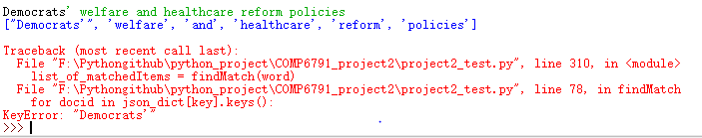
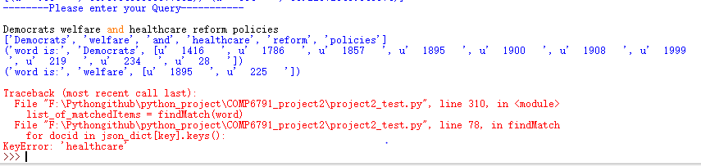
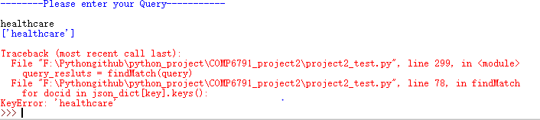
•Drug company bankruptcies(Because that there is not a key named bankruptcies,so have KeyError display)
Thinking: Same as above
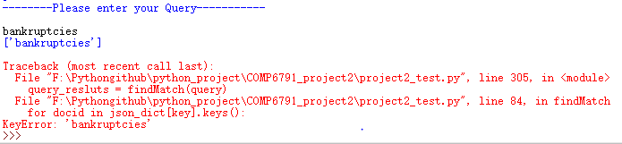
•George Bush
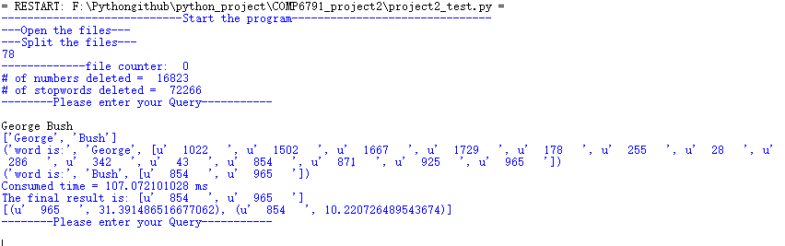
additional testing:
•taiwan
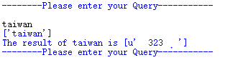
•taiwan textile
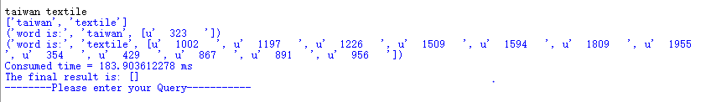
•textile textiles
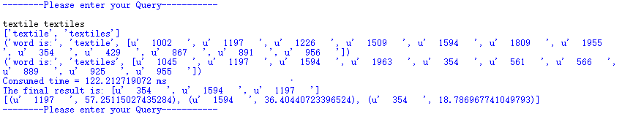
•textile taiwan textiles
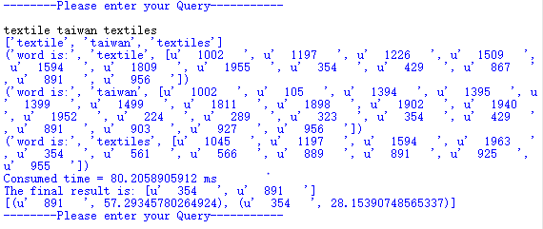
aborted design ideas:
At first, i want to use this type of data structure to store data: {term:{docid:[termfreq, doclen]}}
However, when i do the query part, i find that for each doc, the length of it is fixed, so we don’t need to add it into dictionary and don’t need to make the dictionary complex. So i use {term:{docic: termfrequency}} plus {docid: doclength} , two data structures to do this.

Summary：
For this project, i changed to use python to write the code, which is a great chance to learn python. And i have to say that the length of code by using python is much less than that by using java.

Due to i changed the coding language, i have to write the whole project from beginning,which takes a lot of time.
However, after realizing BM2.5, i understand the idea of search engine, how to return the ranking file by using RSVs score. In addition, realize that the vague searching is useful and important.when a word in the query_list but not in the dictionary, it will disturb the whole query if we don’t use vague query. And we also can use synonym to replace the query word user typed, which will improve the efficiency.

Addition part：
For this time, i know how to fix the encoding and decoding problem(the blue words above),and the new test codes is named “new_project2.py”, which can run the whole .sgm files.

The result of searching “George Bush” as follows:
